1. 
2. 
3.   
   There is where rebasing can help us.
4. 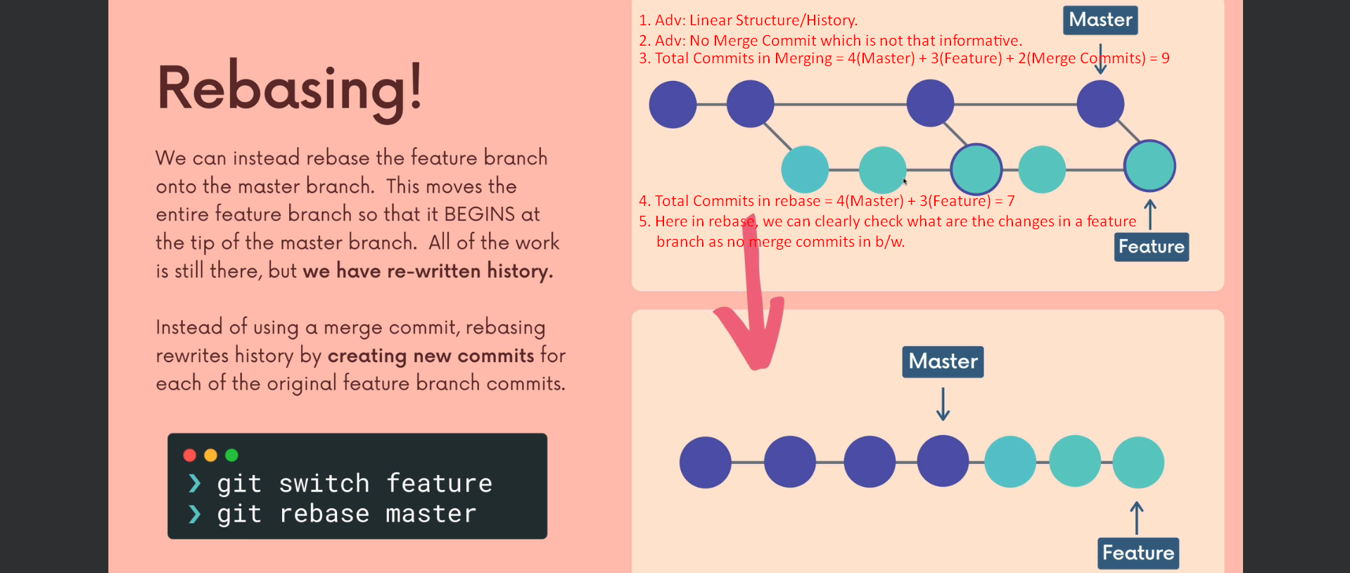
5. Rebase actually rewrite the history by creating a new commit for each commit in the branch which we are rebasing.  
   It may be a problem.  
   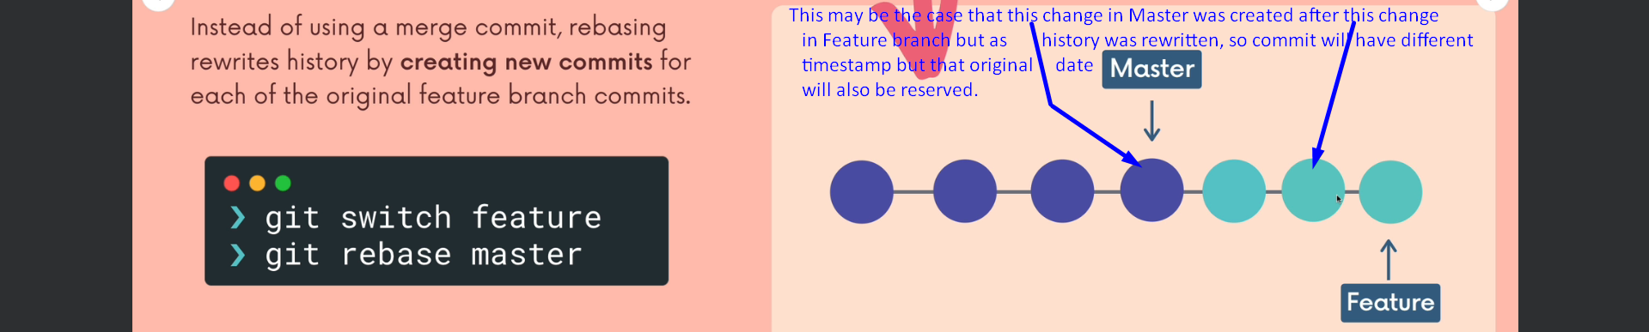
6. 
7. 